NAME: Shriya Ramya Mohan
ROLL NO : 241901106

EXPERIMENT 2
CRACK THE HASHES
AIM:
To install and crack the hashed passwords using John-the-Ripper tool in Kali Linux.
ALGORITHM:
1. Install John-the-Ripper on your system using sudo apt install john
2. Prepare the hash file hashes.txt that is to be cracked.
3. Run John-the-Ripper specifying the path to the wordlist.txt and hashes.txt
4. Monitor the cracking process using status option in another terminal
OUTPUT:
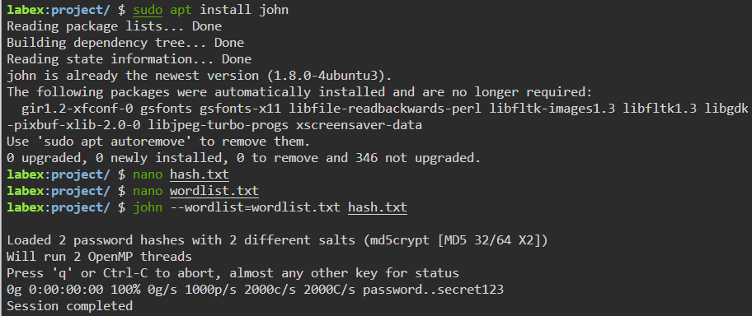

RESULT:
Thus, the hashes have been cracked using john the ripper.

